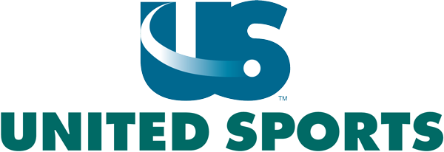

PARKING PASS

OFFICIALS & STAFF

May 23-25, 2026
Approved Dante Surace

